**DX Spots Window**

# Hal Miller KB1ZQ, Geoff Anderson G3NPA, Jim Hargrave W5IFP, Aki Yoshida JA1NLX and Gerry Hohn VE6LB

## 1.0 GENERAL

### 2.10.4 Tooltips

The Tooltips selection opens a panel that enables the operator to customize Windows Tool-Tips. When the cursor is placed over a callsign in the DX Spots column, the country prefix, country name, CQ Zone, continent, status of the country (needed on band, new country, not confirmed), status of IOTA (not worked, not confirmed, not credited),status of WAZ (not worked, not worked on this Band), status of WPX (not worked, not worked on this Band), and the elapsed time the spot has been posted will be displayed as a Windows Tool-Tip as selected.

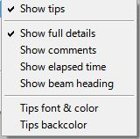

DXSW_14

If you set any text in Comments column of Setup Conditional Country Alert table then this text is displayed. See DXSW_6B or DXSW_15AA

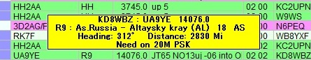

DXSW_14A

Note: Tips font & color and Tips color setting affect not only DX spot window but all Tips used in Logger32.

**Show full details**

With this line checked the tool tips become more informative. They will provide the spotter's call, call of the spotted station,  and frequency of the spot on the first line. The second line will show the prefix of the spotted station, the country, CQ zone, and continent. The third line, if any, will state the operator's need for the spotted station, i.e., Need on 17m.

If this line is not checked then only the prefix of the spotted station, the country, CQ zone, and continent. The second line, if any,  will state the operator's need for the spotted station, i.e., Need on 17m.

**Show elapsed time**

With this option checked the tooltip will contain the time elapsed since the DX spot was reported

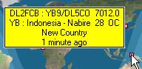

DXSW_15

**Tips font & color**

Sets the tool tips font and color using Windows standard font setup box.

**Tips backcolor**

Sets the back color of the tool tips box displayed using Windows standard color selection box.

Tips font, color and backcolor setting affects appearance not only in tips in DX Spot Window but in all other tips in Logger32.

**Play Ring tones for TALK messages**

This menu selection is a toggle. When checked, a file called RING.WAV is played to give a telephone style "ring tone" whenever a "talk" message is received from the DX cluster.

1. **2.10.6 Setup DX Spot alerts (eMail/SMS/Scratchpad)**

You can receive eMail alerts when your interested DX is spotted or UDP message with new Country/Band/Mode callsign comes in UDP BandMap. (See UDP BandMap section in this Help) The default setting is for Gmail.The Gmail security is set to allow less secure apps to access Gmail.  Go to <https://www.google.com/settings/security/lesssecureapps> and turn it ON.

Click eMail alerts to open the Setup table. Put your Gmail address, Gmail password and optional address where Gmail is to send the alert Email. Do not change your Outgoing SMTP mail server and Outgoing SMTP port if you use Gmail. Click Apply.

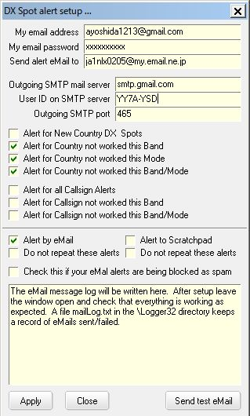

DXSW_16

Logger32 shows the DX spot which is sent to Gmail in lower area in this table and writes the same data in the mailLog.txt in the Logger32 folder. See pic DXSW_16A below.

Send Email to New Country DX Spots, Send eMail for country not worked this Band, Send eMail for country not worked this Mode and/or Send eMail for country not worked this Band/Mode:

If checked then Logger32 sends the spot to Gmail.

Send Email for Callsign Alerts, Send email for not workd this Band Callsign Alerts or Send Email for not worked this Band/Mode Callsign Alerts:

If checked and callsign to be alerted is specified in DX spot audio alert setup table then Logger32 sends the spot to Gmail.

**Note**: These are independent from Credited/confirmed/worked color on/off setting or DX spot audio alert on/off setting.

If you have no Gmail account then you may use your regular email account. Put Outgoing SMTP mail server and Outgoing SMTP port. There may be server which asks you to send a User ID different from the email address. This is another setup example..

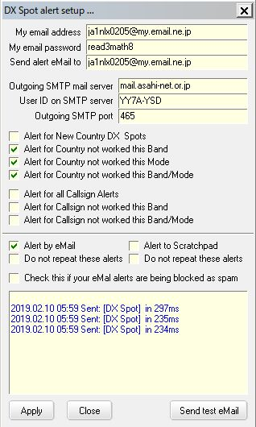

DXSW_16A

If you can send and receive test eMail messages, but DX Spot alerts are not received, it is possible that the SMTP server is blocking the DX Spot messages as spam. Try checking this option.

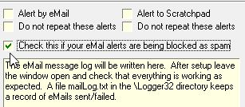

DXSW_16B

Your received eMail looks like this.

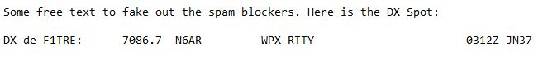

DXSW_16C

### 2.10.7 SH/DX/XX xxx Messages